SEGMENTATION
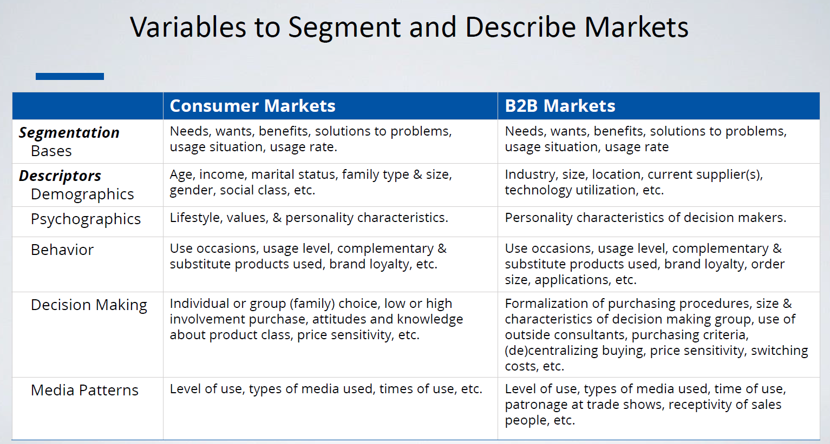
- Discriminant variables: provide additional information about respondets, not related to their needs, but informative.
  - They describe who they are and how they can be related.
  - Age, sex, profession, income, number of children, magazines they read, TV shows they watch, etc.
  - SEGMENTS SHOULD NOT BE FORMED ON THESE VARIABLES.
- Customers are segmented based on their similarities of needs, wants, lifestyles, behavior, etc.
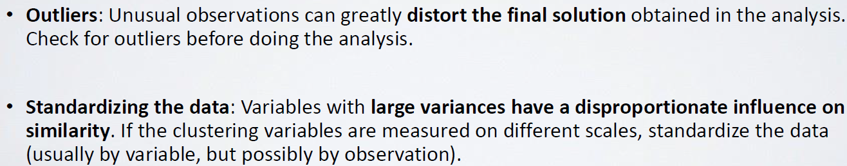


CLUSTERING
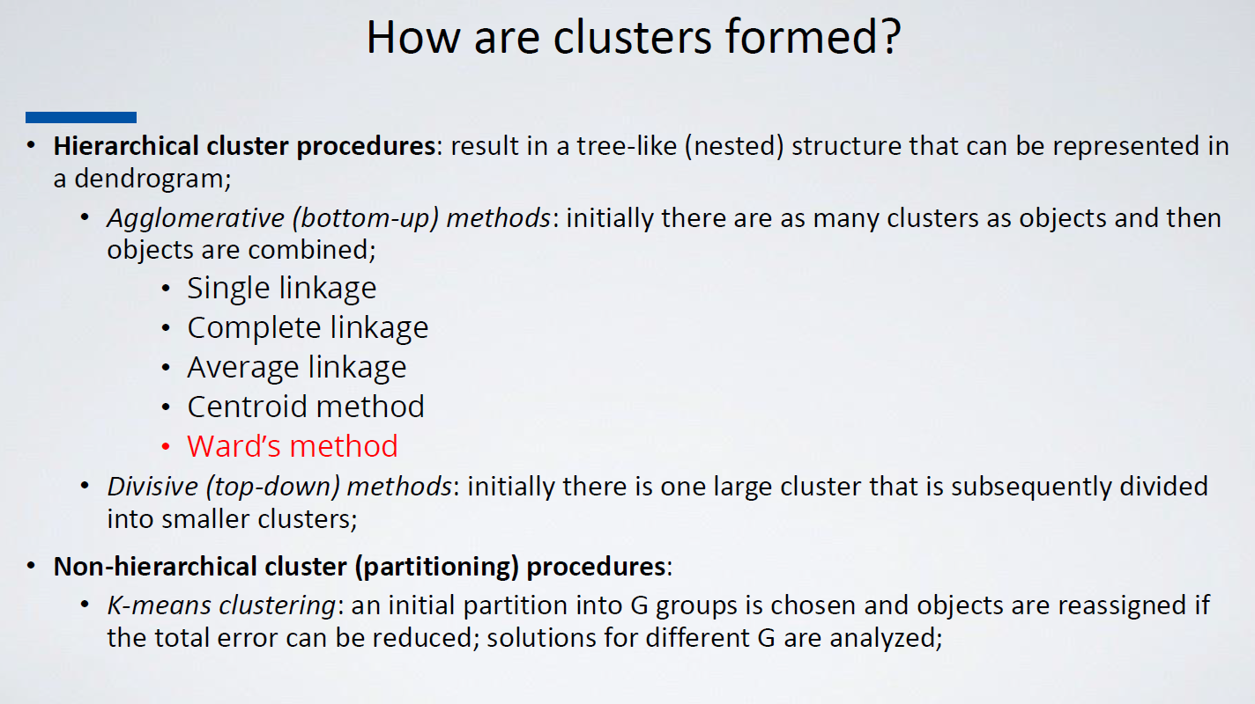

OVERALL IDEA
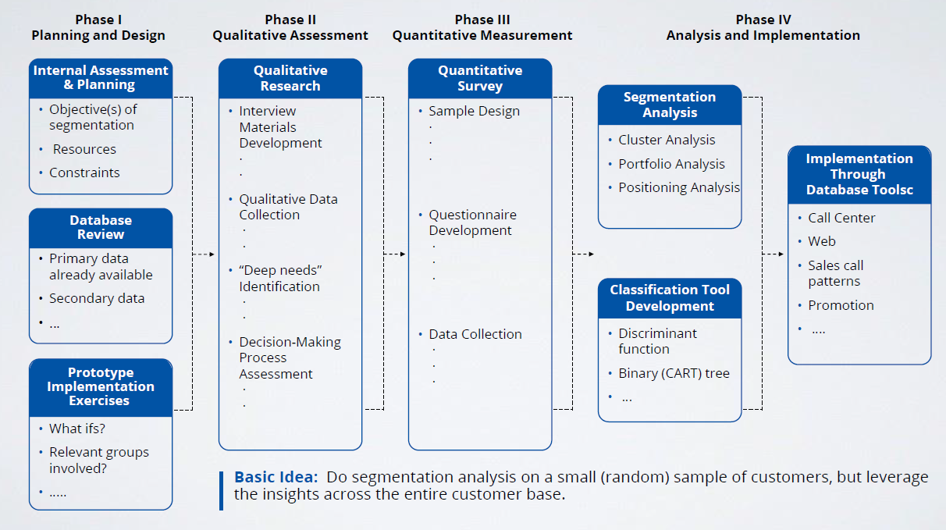

PRICING
